**1.Write a Java program to get a number from the user and print whether it is positive or negative.**

**Test Data  
Input number: 35**

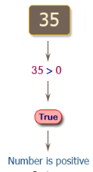

import java.util.Scanner;

public class Exercise1 {

public static void main(String[] args)

{

Scanner in = new Scanner(System.in);

System.out.print("Input number: ");

int input = in.nextInt();

if (input > 0)

{

System.out.println("Number is positive");

}

else if (input < 0)

{

System.out.println("Number is negative");

}

else

{

System.out.println("Number is zero");

}

}

}

**Sample Output:**

Input number: 35

Number is positive

**2.Write a Java program to solve quadratic equations (use if, else if and else).**

**Test Data  
Input a: 1  
Input b: 5  
Input c: 1**

**Pictorial Presentation:**

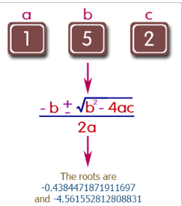

import java.util.Scanner;

public class Exercise2 {

public static void main(String[] Strings) {

Scanner input = new Scanner(System.in);

System.out.print("Input a: ");

double a = input.nextDouble();

System.out.print("Input b: ");

double b = input.nextDouble();

System.out.print("Input c: ");

double c = input.nextDouble();

double result = b * b - 4.0 * a * c;

if (result > 0.0) {

double r1 = (-b + Math.pow(result, 0.5)) / (2.0 * a);

double r2 = (-b - Math.pow(result, 0.5)) / (2.0 * a);

System.out.println("The roots are " + r1 + " and " + r2);

} else if (result == 0.0) {

double r1 = -b / (2.0 * a);

System.out.println("The root is " + r1);

} else {

System.out.println("The equation has no real roots.");

}

}

}

**Sample Output:**

Input a: 1

Input b: 5

Input c: 2

The roots are -0.4384471871911697 and -4.561552812808831

**3.Take three numbers from the user and print the greatest number.**

**Test Data**

**Input the 1st number: 25  
Input the 2nd number: 78  
Input the 3rd number: 87**

**Pictorial Presentation:**

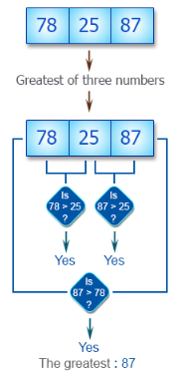

import java.util.Scanner;

public class Exercise3 {

public static void main(String[] args) {

Scanner in = new Scanner(System.in);

System.out.print("Input the 1st number: ");

int num1 = in.nextInt();

System.out.print("Input the 2nd number: ");

int num2 = in.nextInt();

System.out.print("Input the 3rd number: ");

int num3 = in.nextInt();

if (num1 > num2)

if (num1 > num3)

System.out.println("The greatest: " + num1);

if (num2 > num1)

if (num2 > num3)

System.out.println("The greatest: " + num2);

if (num3 > num1)

if (num3 > num2)

System.out.println("The greatest: " + num3);

}

}

**Sample Output:**

Input the 1st number: 25

Input the 2nd number: 78

Input the 3rd number: 87

The greatest: 87

**4.Write a Java program that keeps a number from the user and generates an integer between 1 and 7 and displays the name of the weekday.**

**Test Data  
Input number: 3**

**Pictorial Presentation:**

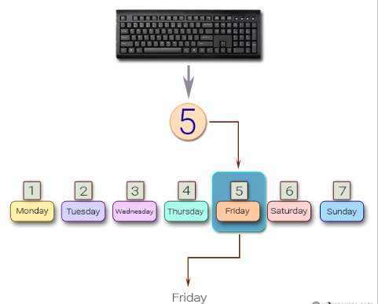

import java.util.Scanner;

public class Exercise5 {

public static void main(String[] args)

{

Scanner in = new Scanner(System.in);

System.out.print("Input number: ");

int day = in.nextInt();

System.out.println(getDayName(day));

}

// Get the name for the Week

public static String getDayName(int day) {

String dayName = "";

switch (day) {

case 1: dayName = "Monday"; break;

case 2: dayName = "Tuesday"; break;

case 3: dayName = "Wednesday"; break;

case 4: dayName = "Thursday"; break;

case 5: dayName = "Friday"; break;

case 6: dayName = "Saturday"; break;

case 7: dayName = "Sunday"; break;

default:dayName = "Invalid day range";

}

return dayName;

}

}

**Sample Output:**

Input number: 3

Wednesday

**5.Write a Java program that reads in two floating-point numbers and tests whether they are the same up to three decimal places.**

**Test Data  
Input floating-point number: 25.586  
Input floating-point another number: 25.589**

import java.util.Scanner;

public class Exercise6 {

public static void main(String[] args)

{

Scanner in = new Scanner(System.in);

System.out.print("Input floating-point number: ");

double x = in.nextDouble();

System.out.print("Input floating-point another number: ");

double y = in.nextDouble();

x = Math.round(x * 1000);

x = x / 1000;

y = Math.round(y * 1000);

y = y / 1000;

if (x == y)

{

System.out.println("They are the same up to three decimal places");

}

else

{

System.out.println("They are different");

}

}

}

**Sample Output:**

Input floating-point number: 25.586

Input floating-point another number: 25.589

They are different

**6.Write a Java program that takes the user to provide a single character from the alphabet. Print Vowel of Consonant, depending on the user input. If the user input is not a letter (between a and z or A and Z), or is a string of length > 1, print an error message.**

**Test Data  
Input an alphabet: p**

**Pictorial Presentation:**

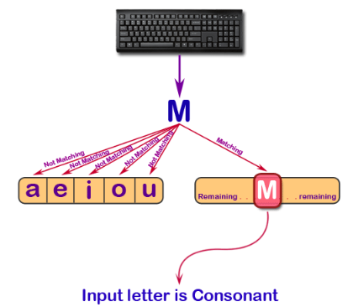

import java.util.Scanner;

public class Exercise8 {

public static void main(String[] args)

{

Scanner in = new Scanner(System.in);

System.out.print("Input an alphabet: ");

String input = in.next().toLowerCase();

boolean uppercase = input.charAt(0) >= 65 && input.charAt(0) <= 90;

boolean lowercase = input.charAt(0) >= 97 && input.charAt(0) <= 122;

boolean vowels = input.equals("a") || input.equals("e") || input.equals("i")

|| input.equals("o") || input.equals("u");

if (input.length() > 1)

{

System.out.println("Error. Not a single character.");

}

else if (!(uppercase || lowercase))

{

System.out.println("Error. Not a letter. Enter uppercase or lowercase letter.");

}

else if (vowels)

{

System.out.println("Input letter is Vowel");

}

else

{

System.out.println("Input letter is Consonant");

}

}

}

**Sample Output:**

Input an alphabet: P

Input letter is Consonant

**7.Write a Java program that takes a year from user and print whether that year is a leap year or not.**

**Test Data  
Input the year: 2016**

**Pictorial Presentation:**

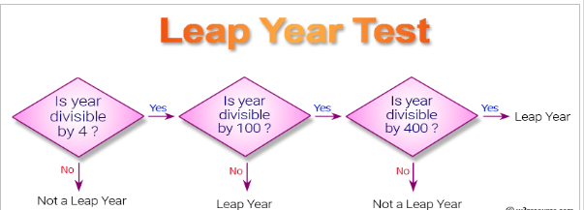

import java.util.Scanner;

public class Exercise9 {

public static void main(String[] args)

{

Scanner in = new Scanner(System.in);

System.out.print("Input the year: ");

int year = in.nextInt();

boolean x = (year % 4) == 0;

boolean y = (year % 100) != 0;

boolean z = ((year % 100 == 0) && (year % 400 == 0));

if (x && (y || z))

{

System.out.println(year + " is a leap year");

}

else

{

System.out.println(year + " is not a leap year");

}

}

}

**Sample Output:**

Input the year: 2016

2016 is a leap year

**8.Write a program in Java to display the first 10 natural numbers.**

**Pictorial Presentation:**

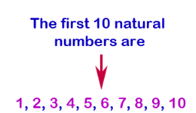

public class Exercise10 {

public static void main(String[] args)

{

int i;

System.out.println ("The first 10 natural numbers are:\n");

for (i=1;i<=10;i++)

{

System.out.println (i);

}

System.out.println ("\n");

}

}

**Sample Output:**

The first 10 natural numbers are:

1

2

3

4

5

6

7

8

9

10

**9.Write a program in Java to display n terms of natural numbers and their sum.**

**Test Data  
Input number: 7**

**Pictorial Presentation:**

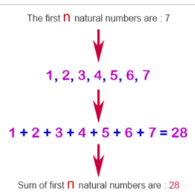

import java.util.Scanner;

public class Exercise11 {

public static void main(String[] args)

{

int i, n, sum=0;

{

Scanner in = new Scanner(System.in);

System.out.print("Input number: ");

n = in.nextInt();

}

System.out.println("The first n natural numbers are : "+n);

for(i=1;i<=n;i++)

{

System.out.println(i);

sum+=i;

}

System.out.println("The Sum of Natural Number upto "+n+ " terms : " +sum);

}

}

**Sample Output:**

Input number: 7

The first n natural numbers are : 7

1

2

3

4

5

6

7

The Sum of Natural Number upto n terms : 28

**10.Write a program in Java to display the cube of the number upto given an integer.**

**Test Data  
Input number of terms : 4**

**Pictorial Presentation:**

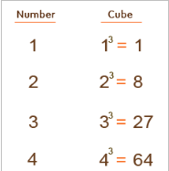

import java.util.Scanner;

public class Exercise13 {

public static void main(String[] args)

{

int i,n;

System.out.print("Input number of terms : ");

Scanner in = new Scanner(System.in);

n = in.nextInt();

for(i=1;i<=n;i++)

{

System.out.println("Number is : " +i+" and cube of " +i+" is : "+(i*i*i));

}

}

}

**Sample Output:**

Input number of terms : 4

Number is : 1 and cube of 1 is : 1

Number is : 2 and cube of 2 is : 8

Number is : 3 and cube of 3 is : 27

Number is : 4 and cube of 4 is : 64